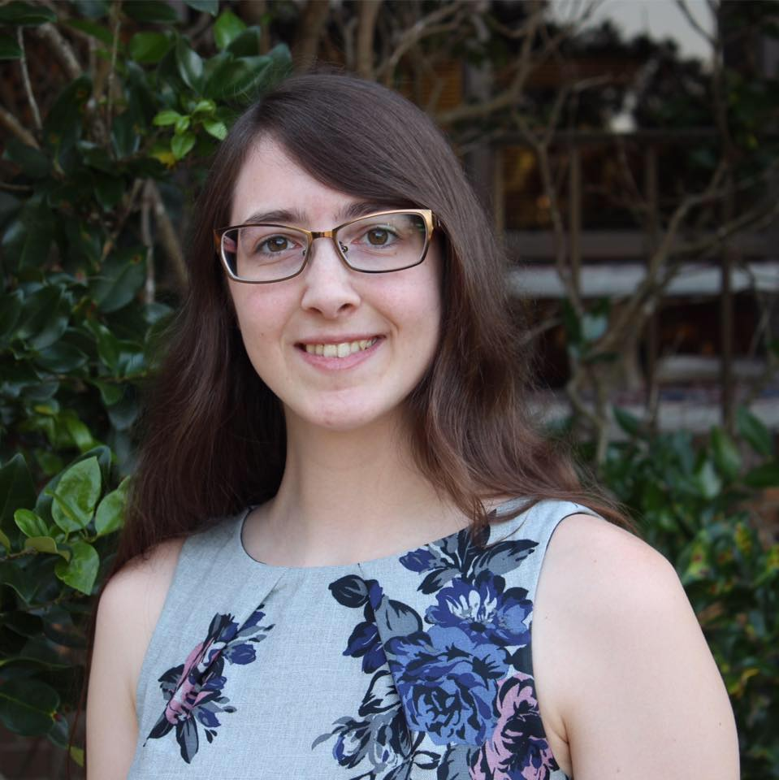
Lindsey K. Bullard
6700 Wall Street
Apartment 4F, Mobile, AL 36695
205.915.9607
lkb1322@jagmail.southalabama.edu

Career Objective:
My immediate goal is to gain as much knowledge as I can about the field of Broadcast Journalism. My long-term goal is to work as a journalist at a radio or television news station.

Education

University of South Alabama, Mobile, AL Graduating Dec 2017
B.A. in Communication, Concentration in Broadcast Journalism
Minor in Criminal Justice, GPA: 4.00

Experience

Intern at WZEW 92.1 FM (92ZEW), Mobile, AL Aug 2017-Dec 2017
News Director/Staff at WJGR-LP 97.1 FM (The Prowl), Mobile, AL Oct 2016-Dec 2017

Skills

Promotion
- Participated in multiple remotes for 92ZEW during my internship, Fall 2017
- Helped promote The Prowl for College Radio Day 2016 and 2017

Microsoft Programs and EZ News
- Know how to use Microsoft programs to create news and broadcast scripts
- Know how to use EZ News script writing software

Final Cut Pro, Adobe Audition, Web Design and Production
- Know basics of editing video and audio in Final Cut Pro
- Can record and edit audio files in Adobe Audition
- Know how to write basic HTML code
- Can create website and social media content
- Can run TelePrompter
- Can operate studio cameras and field cameras

Proofreading and Editing
- Have examined and edited other peers' work
- Have helped others with developing topics for their work
- Know basic format of hard and soft news pieces
- Know Associated Press Style for news writing

Time Management and Organization
- Can work towards a deadline efficiently
- Can manage multiple projects at a time

Communication and Teamwork
- Effective at communicating with others and problem solving
- Can work well in a team or individually as necessary
- Can serve as leader or follow orders from others as needed

Activities and Associations
- Member, Alpha Chi National College Honor Society, Oct 2016 – Present
Awards and Commendations
- Presidential Scholarship, University of South Alabama, Fall 2014-Present
- President’s List, University of South Alabama, Fall 2014-Present
References available upon request

