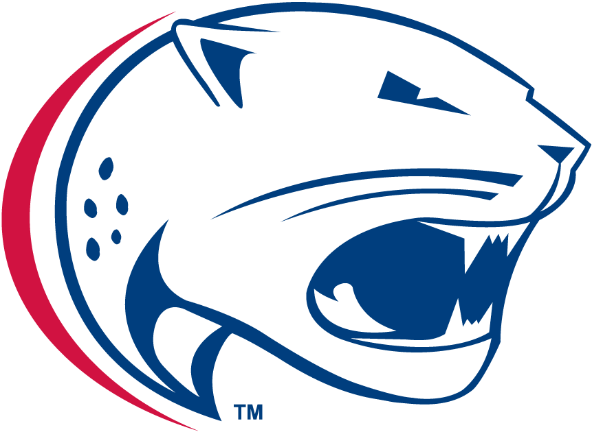
USA Film Club

Contact | Lindsey Bullard
Telephone | 251-870-5555
Cell | 251-558-5555
Email | lbullard@southal.edu
Website | www.usafilmclub.edu
For release at 12:00 p.m.
Tuesday, Oct. 27

USA FILM CLUB TO HOSt HALLOWEEN MOVIE NIGHT

October 27, 2015–The USA Film Club will host their second annual spooky movie marathon on Halloween starting at 7:30 pm and lasting until 1:00 am.
The marathon will be held in the back of the Student Center, weather permitting.
Admission is free and the movies being shown include Hocus Pocus, Beetlejuice, and The Rocky Horror Picture Show. After each film, there will be a 15-minute break.
All students and faculty may attend. There will be food and soft drinks available for a donation of $5 per person. Donations will help the USA Film Club host more events in the future.
“Last year we had a great turnout. Over 150 students attended. We’re hoping for even more this year,” Andy Williams, USA Film Club president, said.
The USA Film Club was established in 2014 and is always looking for new members. If you would like more information on this event or future membership, please contact Lindsey Bullard at 251-870-5555 or email at lbullard@southal.edu.
# # #

